**Experiment 2.2**

**Student Name: Sahul Kumar Parida UID: 20BCS4919**

**Branch: CSE Section/Group: WM904/B**

**Semester: 5th Date of Performance: 09/10/22**

**Subject Name: Machine Learning Lab Subject Code: CSP-317**

**1. Aim/Overview of the practical:**

To implement Naive Bias Algorithm.

# 2. Task to be done:

i) To calculate the probabilities required by the Naive Bayes algorithm.

ii) To implement the Naive Bayes algorithm for prediction.

# 3. Apparatus/Simulator used:

* Jupyter Notebook/Google Collab
* Sklearn - Scikit-learn (Sklearn) is the most useful and robust library for machine learning in Python. It provides a selection of efficient tools for machine learning and statistical modeling including classification, regression, clustering and dimensionality reduction via a consistence interface in Python.

**4. Code and Output:**

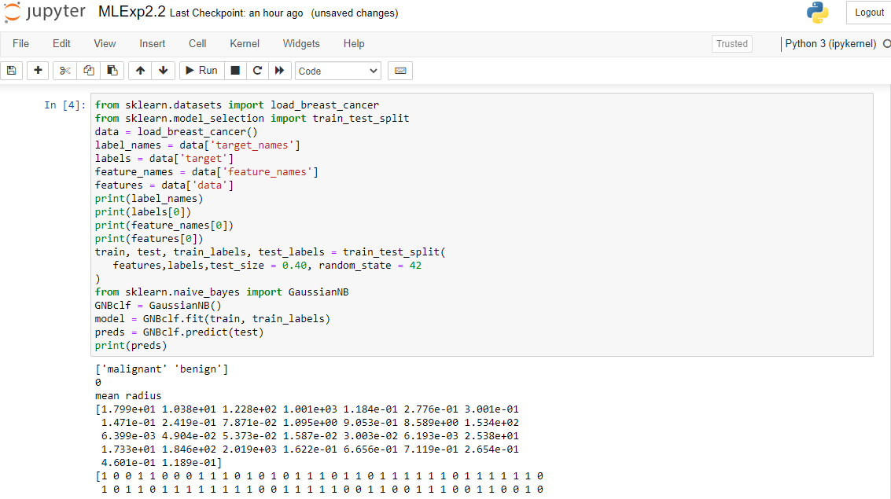

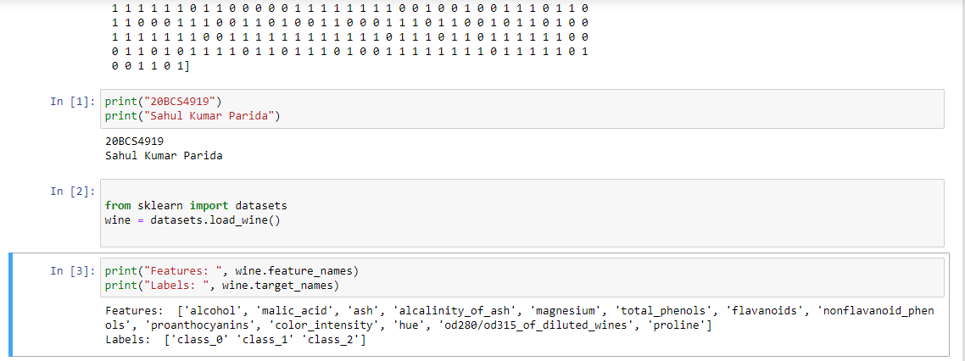

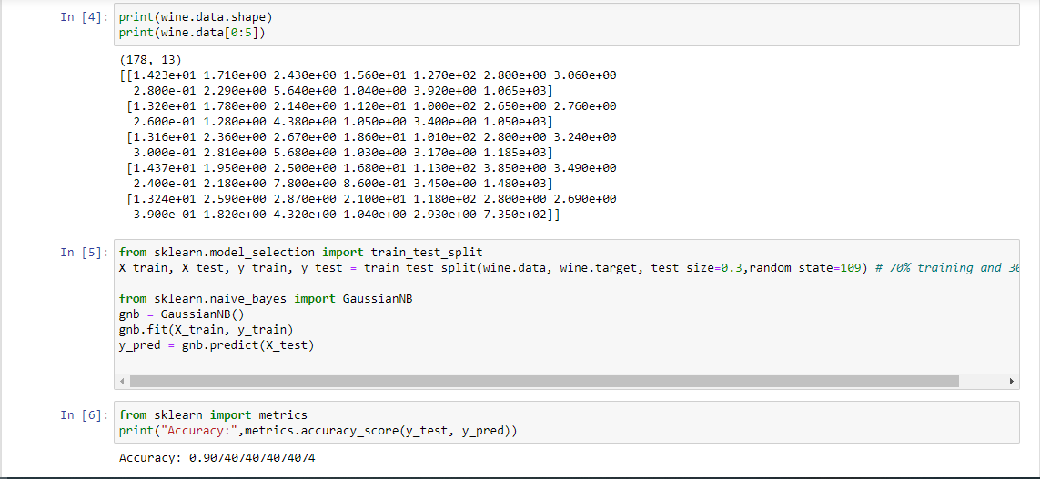

* Naïve Bayes algorithm is a supervised learning algorithm, which is based on Bayes theorem and used for solving classification problems.
* It is a probabilistic classifier, which means it predicts on the basis of the probability of an object.

The Naïve Bayes algorithm is comprised of two words Naïve and Bayes, which can be described as:

* **Naïve**: It is called Naïve because it assumes that the occurrence of a certain feature is independent of the occurrence of other features. Such as if the fruit is identified on the bases of colour, shape, and taste, then red, spherical, and sweet fruit is recognized as an apple. Hence each feature individually contributes to identify that it is an apple without depending on each other.
* **Bayes**: It is called Bayes because it depends on the principle of [Bayes' Theorem](https://www.javatpoint.com/bayes-theorem-in-artifical-intelligence).

**Learning outcomes (What I have learnt):**

1. Learning about different library/packages of python.
2. Learning about the different methods, that are needed to analyze the given dataset.
3. Learning about different Machine Learning Functions.
4. We learn to work with multi-dimensional datasets.
5. Usage of Naive Bias Algorithm to classify the type of wine.